**Sensitivity Analysis solutions - EXCEL**

* Saideva Sathvik.R, I MSc., 22234

Problem 1: (Tables and Chairs)

Solution:

LP SOLVER Solution:

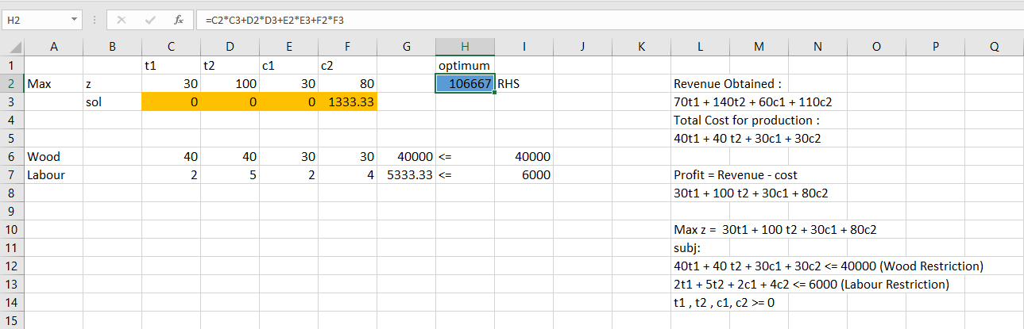

**Question:**

A Company manufactures tables and chairs. A table requires 40 board ft of wood, and a chair requires 30 board ft of wood. Wood may be purchased at a cost of $1 per board ft, and 40,000 board ft of wood are available for purchase. It takes 2 hours of skilled labor to manufacture an unfinished table or an unfinished chair. Three more hours of skilled labor will turn an unfinished table into a finished table, and 2 more hours of skilled labor will turn an unfinished chair into a finished chair. A total of 6,000 hours of skilled labor are available (and have already been paid for). All furniture produced can be sold at the following unit prices:

1. unfinished table, $70;
2. finished table, $140;
3. unfinished chair, $60;
4. finished chair, $110.

Formulate an LP that will maximize the contribution to profit from manufacturing tables and chairs.

**Solutions:**

1. Formulated LP:

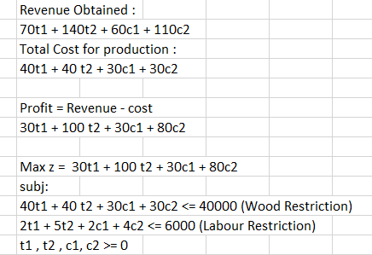

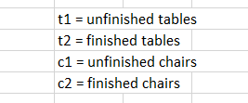

**Sensitivity Report:**

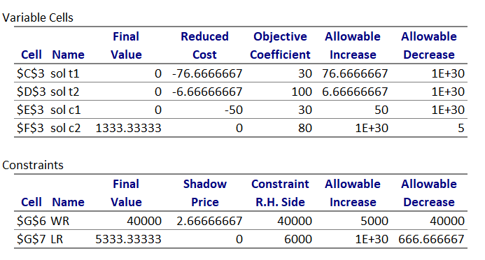

**Excel Solution:**

Excel finds the answer to the problem to ***construct only finished chairs*** **(1333.333).**

**The profit is *$106,666.67.***

1. What would happen if the price of unfinished chairs went up?
2. Currently they sell for $60. Allowable increase in the coefficient is $50, ***it would not be profitable to produce them*** even if they sold for the same amount as finished chairs.
3. What would happen if the price of unfinished tables went up?
4. The allowable increase is more than 70. Even if you could sell unfinished tables for more than finished tables, it is not advisable to sell them. It is not enough to make unfinished tables more profitable than finished tables,

***you must make them more profitable than finished chairs.***

1. What if the price of finished chairs fell to $100?
2. This change would alter your production plan: it involves a $10 decrease in the price of finished chairs and the allowable decrease is only $5. The best thing to do is specialize in finished tables, producing 1000 and earning $100,000.If you continued with the old production plan your profit would be 70 × 1333 1/3 = 93, 333 1/3, ***so the change in production plan was worth more than $6,000.***
3. How would profit change if lumber supplies changed?
4. The shadow price of the lumber constraint is $2.67.

The range of values for which the basis remains unchanged is 0 to 45,000. If the lumber supply went up by 5000, then

you would continue to specialize in finished chairs, and your

profit would go up by $2.67 × 5000 = $10, 333.***If lumber supply decreased, then your profit would decrease.***

1. How much would you be willing to pay an additional carpenter?
2. You are not using the labor that you have, ***so no need of an additional carpenter.***
3. Suppose that industrial regulations complicate the finishing

process, so that it takes one extra hour per chair or table to turn an unfinished product into a finished one. How would this change your plans?

1. the amount of labor required to create a finished product increases by one unit. The change cannot make profit better. To produce 1,333.33 finished chairs, you’ll need 1,333.33 extra hours of labor, which we do not have.

**Excel Solution:**

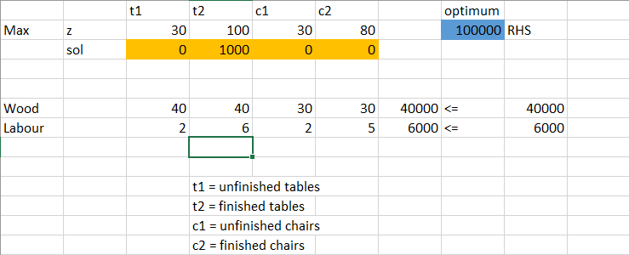

it turns out that it becomes optimal to specialize in finished tables, producing 1000 of them and earning ***$100,000.***

1. The owner of the firm comes up with a design for a beautiful hand-crafted cabinet. Each cabinet requires 250 hours of labor (this is 6 weeks of fulltime work) and uses 50 board feet of lumber. Suppose that the company can sell a cabinet for $200, would it be worthwhile?
2. The coefficient of cabinets in the objective function is 150, which reflects the sale price minus the cost of lumber.

The Final Value increases to ***106712.3288***

The solution involved reducing the output of unfinished chairs to **1328.767123** and increasing the output of cabinets to **2.73972602739726**.



